To: Dr. Derek Ross

From: Lizzie McGlynn

Date: October 27, 2024

Subject: ENGL 7000 Final Editing Report

## Introduction

An editor wears many hats. They plan, coordinate, and revise written or visual materials for publication or presentation. While doing so, editors must always keep in mind that individuals have varying abilities and needs. One major responsibility of an editor is ensuring that documents are accessible to all audiences, allowing everyone to understand the author's intended message. Through my experience with disability, I’ve come to appreciate the critical accessibility standards that editors must uphold. To be an editor, you need to address these requirements, as some audience members may face challenges such as impaired vision, necessitating accommodations like proper speech dictation, alt text for images, and typography that is easily readable. Accessibility considerations are extensive, and each is essential to making content inclusive.

Running documents through an accessibility check is always beneficial, as it confirms whether they meet the required standards. Accessibility tools can identify elements that need improvement and provide guidance, ensuring content is inclusive for all. This process has profoundly shaped my understanding of what it means to be an editor: creating documents that meet essential accessibility standards and fostering inclusivity for every audience.

To truly be an editor, one must ensure that every document meets all accessibility rules, making inclusion a non-negotiable priority. Through this lens, accessibility becomes not just a feature of good editing but its very foundation.

## Legible Text

An accessible document accommodates readers with low or no vision, dyslexia, or color blindness by using clear, logically ordered headings. Headings provide structure and facilitate navigation through assistive technologies like screen readers. These tools allow users to skip redundant information, access specific sections, or gain a comprehensive overview of the content (Yale University; UNC School of Medicine).

Properly structured headings are essential to accessibility compliance. There are six levels of headings, ranging from H1 (the most important) to H6 (the least important). These must be used in descending order without skipping levels. For instance, an H4 should only follow an H3. Most web pages should begin with an H1, which conveys the broad concept of the page. As shown in Figure 1, the use of H1, H2, H3, and H4 headings demonstrates a logical hierarchy, further organizing the main content into clearly defined sections while maintaining proper structure and flow (UNC School of Medicine).

Figure 1: Example of a structured heading hierarchy (H1 to H4)

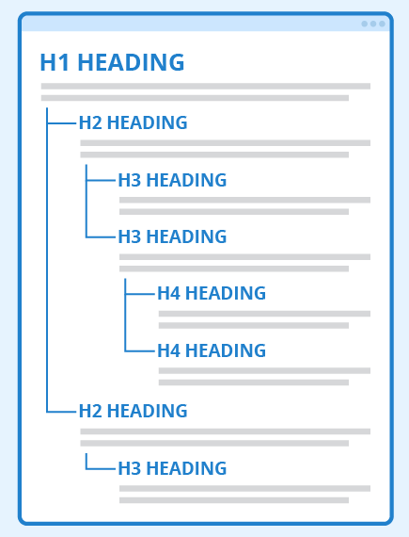

For screen reader users, headings provide a framework for navigating and understanding the relationships between sections. They outline the document’s structure, making content more accessible and user-friendly. This logical organization also improves the experience for users with cognitive disabilities, as visibly distinct headings make it easier to process and retain information.

In terms of being an editor, ensuring that a document is accessible involves using proper heading structure and formatting to support a wide range of readers, including those with low or no vision, dyslexia, or color blindness. Editors must focus on the clear, logical organization of headings to facilitate navigation by screen readers and assistive technologies, which help users quickly locate sections, skip redundant information, and understand the document’s overall structure (Yale University, n.d.; UNC School of Medicine, n.d.).

As an editor, it’s essential to enforce the correct use of heading levels (H1-H6) in descending order without skipping levels. This ensures that each section of the document is properly indexed and helps users with cognitive disabilities better process the content. The editor’s role in maintaining this logical flow and hierarchy also aligns with accessibility compliance standards, ultimately enhancing the document’s readability and usability for all users. By structuring the document appropriately, an editor can improve the experience for individuals relying on assistive technologies and contribute to more inclusive communication.

## Accessible Typography

Accessible typography ensures textual information is readable by diverse audiences, including those with low vision or dyslexia. Sans-serif fonts, which lack decorative strokes, enhance clarity and reduce visual strain, making them particularly beneficial for digital content where on-screen text often appears smaller and requires higher legibility (U.S. General Services Administration, n.d.). For editors, this highlights the responsibility of ensuring that text design serves the needs of all users, not just those with typical vision.

Accessibility standards such as the Americans with Disabilities Act (ADA) and the Architectural Barriers Act (ABA) emphasize the use of sans-serif fonts in specific contexts, acknowledging their benefits for individuals with visual impairments. Editors play a critical role in adhering to these standards by selecting fonts that enhance readability and ensure content is accessible to everyone, including those relying on assistive technologies (Margau, 2024). This includes choosing high-contrast color combinations, like black text on a white background, and ensuring characters are large and well-spaced to support users with low vision. Editors must also consider flexibility, ensuring fonts and colors allow for user adjustments to accommodate personal needs.

While serif fonts can be easier to read for individuals with good vision, they often hinder readability for those with low vision. Consequently, sans-serif fonts are the preferred choice for headings and digital content, as they prioritize accessibility without sacrificing design aesthetics (U.S. General Services Administration, n.d.). An editor must balance functionality with visual appeal, ensuring the typography aligns with the needs of all users.

Some popular accessible fonts include Arial, Verdana, Tahoma, and Open Sans (Margau, 2024). For example, Arial’s simple sans-serif design and clear distinctions between letters make it highly accessible, while Verdana’s wide character spacing and bold outlines improve readability for those with visual impairments (Ellis, 2023). Editors must understand these distinctions to choose the right font for each circumstance, ensuring clarity and inclusivity.

In my group’s publication, *Culinary Chronicles*, we used Arial, Georgia, and Times New Roman to suit different purposes. Serif fonts, like Georgia and Times New Roman, convey tradition and elegance, making them ideal for the narrative elements of the cookbook. Times New Roman was chosen for basal text, like recipes and anecdote content, because its high contrast and legibility at standard sizes make it accessible for most readers. Arial was used for shorter, high-priority content, such as author names and ingredient lists, due to its clean, modern appearance and ease of readability for those with visual impairments or dyslexia. Georgia, with its larger x-height and strong letterforms, was used for titles and headings, adding sophistication while ensuring readability in both print and digital formats.

As Figure 2 shows, the distinct characteristics of serif fonts, like Georgia and Times New Roman, and the sans-serif fonts Arial and Verdana highlight their differences in readability and accessibility. While Verdana and Cambria weren’t used in *Culinary Chronicles*, its wide spacing and clean design exemplify the accessibility considerations that informed the choice of Arial for high-priority content in the publication.

Figure 2: Comparison of serif (Georgia, Times New Roman, Cambria) and sans-serif (Arial, Verdana) fonts

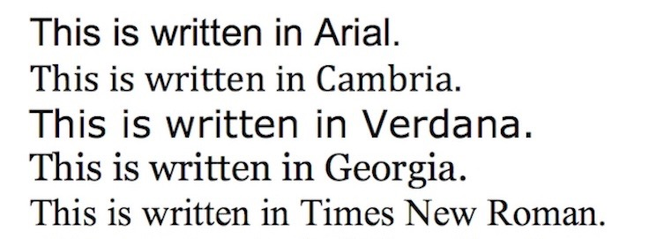

Typography decisions extend beyond font choice to include line spacing, alignment, and paragraph length. Generous spacing and left-aligned text improve readability, especially for individuals with cognitive disabilities. By attending to these details, my group, as editors of the publication, ensured the content was not only visually appealing but also accessible to a wide audience.

To be an editor is to be a mediator between design and audience needs, balancing tradition with innovation and accessibility with aesthetics. Editors must consider how their decisions impact the usability of content, ensuring it serves all readers effectively. Typography is a fundamental part of this process, as thoughtful choices in font, spacing, and alignment can transform a publication from merely functional to truly inclusive.

## Screen Readers & Text-to-Speech

Screen readers are essential tools for individuals with disabilities, converting written text into audio to make digital content more accessible. These tools allow users to interact with web pages by reading text, navigation elements, forms, and image alt text aloud. For example, screen readers enable users to jump directly to specific sections, bypassing repeated elements like headers or sidebars (Wake Forest University, n.d.; Recite Me, 2024).

In ENGL 7000: Technical Editing, we experimented a little bit with text-to-speech technology and a real screen reader. While the text-to-speech tool struggled with mispronunciations and had a choppy rhythm, it highlighted the importance of auditory input in catching typos and assessing the flow of written content. By offering a fresh perspective, these tools help editors identify areas for improvement and enhance the overall quality of their work (Puglisi, 2017).

Screen readers also support individuals with mobility or learning disabilities, as well as those in environments where visual engagement is not possible. For example, my friend Ansley, who was born blind, relies on a screen reader to compose and edit her songs. She uses JAWS (Job Access With Speech), the world’s most popular screen reader, which supports popular word processing and music software. JAWS provides speech and Braille output for various applications (Freedom Scientific, n.d.). Ansley also uses Cakewalk, where JAWS scripting helps integrate features into the music production software, making it easier for her to interact with notation (American Foundation for the Blind, n.d.).

Similarly, a past friend with cerebral palsy used text-to-speech software called Voice Dream Reader to read books, as her cognitive limitations made traditional reading difficult. Voice Dream Reader allows users to listen to PDFs, web pages, and books. The app is designed to be highly speech-friendly, which was essential in her case. All buttons are clearly labeled, and several features are specifically designed for VoiceOver users. My friend mainly used this app to read E-books (Horton, n.d.).

This emphasis on accessibility also became clear during my work on a cookbook project, where the importance of making content inclusive was underscored by our initial oversights. While creating the cookbook, we did not prioritize designing the layout with screen reader users in mind. This decision was a missed opportunity to enhance accessibility. Unlike tools such as Voice Dream Reader, our project was not equipped to support individuals who rely on assistive technologies, leaving it inaccessible to many users. In hindsight, this oversight made me realize the critical need for inclusive design practices that ensure digital content, including cookbooks, can be enjoyed by all users. These examples show how editors can use technology to bridge accessibility gaps. By understanding how screen readers function and adjusting content accordingly, editors can greatly enhance the inclusivity of their work. In addition, embracing accessible tools and content formats helps ensure that a wider range of users can engage with and benefit from digital materials. This commitment to inclusivity fosters a more equitable experience for everyone, regardless of ability. Editors play a vital role in promoting these principles, shaping a more accessible and user-friendly digital landscape (Puglisi, 2017; Wake Forest University, n.d.; Recite Me, 2024).

## Alternative Text

Alt text is a prime example of how an editor shapes the accessibility and usability of content, demonstrating the pivotal role editors play in bridging gaps between diverse audiences and digital materials. To be an editor means to ensure that content serves its intended purpose for all users, regardless of their abilities or how they access information.

Writing alt text requires editors to deeply understand the image’s purpose and context. They must balance clarity and conciseness with accuracy, crafting descriptions that convey essential details without overwhelming the user. This reflects the editor’s responsibility to make content meaningful and inclusive, aligning with accessibility standards like the ADA and Section 508 (Content Creation, 2023). By taking the time to write thoughtful alt text, editors ensure that visual content can be understood by individuals using screen readers, as well as those in situations where images cannot be displayed.

The editor’s role extends beyond creating accessible content; it involves understanding and implementing guidelines that enhance inclusivity. For instance, they must decide when an image requires detailed descriptions, when a simple placeholder suffices, and how to handle complex visuals that may require supplementary resources (Elliott & Hogle, 2020). This decision-making process underscores the editor's dedication to delivering equitable content for all users.

In our cookbook publication project, my group overlooked the importance of alt text, failing to include it for the images we used. This lack of consideration meant that our cookbook was inaccessible to individuals relying on screen readers, as they would not have been able to understand the visual context or recipe instructions. Reflecting on this experience, I recognize how vital it is for editors to prioritize accessibility in every stage of a project. This oversight demonstrated how a lack of attention to accessibility can create barriers, excluding a portion of the audience who might have benefited from the content.

Figure 3 illustrates the practical side of this responsibility, showing the pop-up box where users can add alt text by selecting "View Alt Text." This feature highlights how editors ensure accessibility is embedded in every aspect of content creation, from conception to publication.

In essence, being an editor means acting as a steward of communication, ensuring that all content, whether visual or textual, is accessible, equitable, and inclusive. Alt text serves as a tangible reminder of the editor’s influence in creating a digital world where no one is left out.

Figure 3: The pop-up box for adding alt text

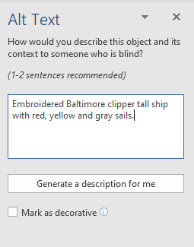

## Color Contrast

Color contrast significantly impacts accessibility, particularly for users with low vision or color blindness. Editors are responsible for ensuring that text contrasts sharply with its background, improving readability and ensuring that all users, regardless of their visual abilities, can access the content. High-contrast combinations like black text on a white background offer the most visibility, though other combinations, such as dark blue on light yellow, can also be effective (Color Contrast, 2023).

Poor contrast can render text illegible, which creates barriers for users with visual impairments. Editors must avoid color combinations like red and green or blue and yellow, which can be difficult for colorblind individuals to distinguish. Additionally, relying solely on color to convey important information is discouraged. Editors can overcome this by using bold text, underlining, or patterns alongside color to differentiate elements. These approaches ensure that critical content is accessible even if the user cannot perceive certain colors.

To further enhance accessibility, editors should avoid using photographic or gradient backgrounds behind text, as these can diminish legibility. Solid, high-contrast backgrounds are ideal because they maintain visual clarity. Larger font sizes, particularly those using sans-serif fonts like Arial, also improve readability. These design choices reduce eye strain and make content easier to process, especially for users with cognitive disabilities or visual impairments (Color Contrast, 2023)

The Web Content Accessibility Guidelines (WCAG) set specific contrast ratios for text and backgrounds to ensure readability. These standards are designed to create a consistent and accessible experience for users across various devices and settings. Following these guidelines benefits all users by enhancing content clarity and reducing the cognitive load of reading.

The *Culinary Chronicles* publication is an exemplary model of accessible color contrast. The pairing of black text on a light-yellow background, as shown in Figure 4, ensures that the main content is readable for users with low vision or visual impairments. This color combination provides maximum contrast, making it easier to read the text, even in low-light conditions or on digital screens where text can appear smaller. This contrast minimizes eye strain and enhances overall readability.

Figure 4: Recipe instructions in black text on a light-yellow background

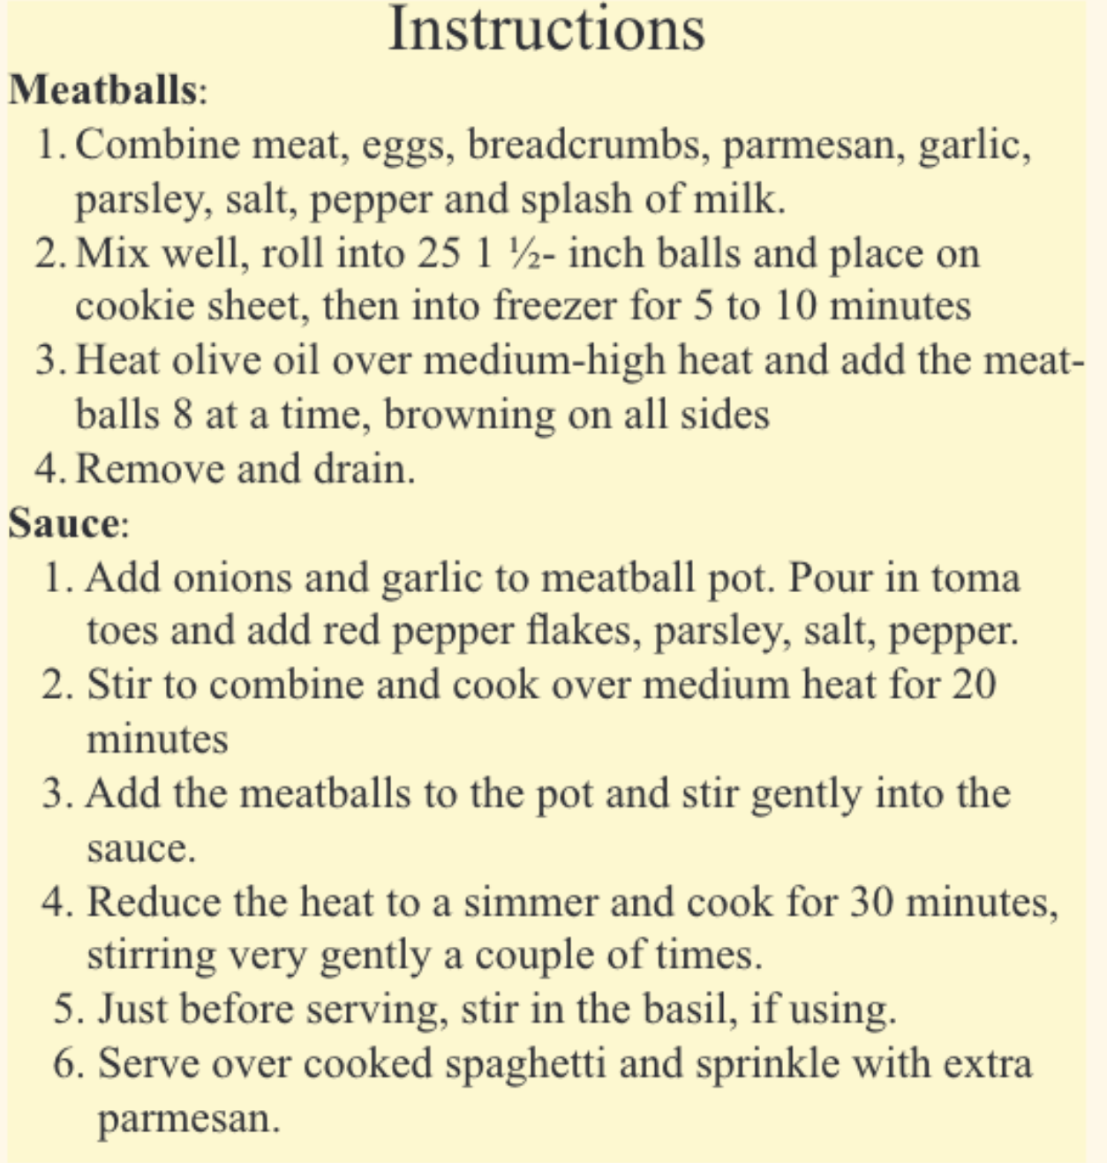

For headings, subheadings, and decorative elements, the publication uses muted terracotta and olive green. These earthy tones not only create a visually appealing design but also maintain accessibility. The contrast between the muted colors and light backgrounds ensures that the key elements stand out without overwhelming the reader. These colors are carefully chosen to remain distinguishable for individuals with red-green color blindness, making the design more inclusive.

Additionally, the color palette used in *Culinary Chronicles* supports a clear visual hierarchy. Terracotta and olive green draw attention to headings and important details, while black and light yellow are used to ensure consistent readability throughout the publication. The design balances both aesthetic appeal and functionality, creating a cohesive and engaging experience for all readers.

By thoughtfully integrating these color choices, my group and I while designing *Culinary Chronicles* demonstrated our roles in ensuring the publication was accessible and welcoming to diverse audiences. Editors contribute to an equitable digital experience by prioritizing readability and inclusivity in every design decision. Their work ensures that no user is excluded from engaging with content, fulfilling the editor’s responsibility to create accessible, effective communication that can be enjoyed by everyone.

## Links, Buttons, and Forms

Figure 5: Accessible vs. inaccessible button and link text

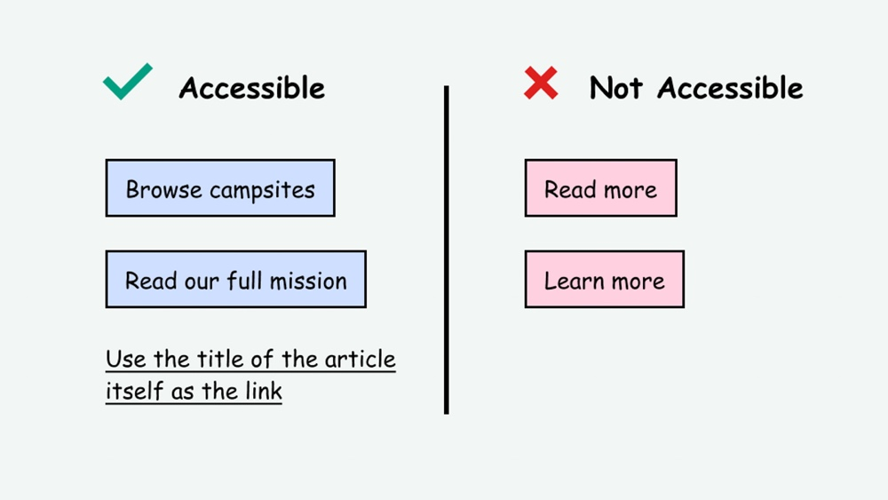

An editor plays a vital role in crafting content that is accessible and meaningful to diverse audiences. For instance, accessible hyperlinks must use descriptive text that clearly indicates their purpose. As shown in Figure 5, vague phrases like “click here” or “read more” should be avoided in favor of specific labels such as “browse campsites” or “read our full mission.” An editor ensures that hyperlinks are both informative and contextually relevant, improving navigation for all users, particularly those relying on screen readers who navigate links out of sequence (Accessibility Bytes No. 4: Descriptive Links and Hypertext, n.d.).

An editor’s attention to detail extends to formatting decisions, such as avoiding fully capitalized link text. All-caps links can be harder to read for most users and pose additional challenges for those with reading disabilities. Furthermore, screen readers may read fully capitalized links letter by letter, making comprehension difficult. Editors also guide the choice of link text, steering away from raw URLs, which can be confusing when read by screen readers. Instead, editors advocate for readable, descriptive link text unless the URL itself conveys critical information. These decisions reflect the editor’s responsibility to prioritize clarity and accessibility (NYS Education Department, n.d.).

In addition to text, an editor must evaluate the usability of design elements like buttons. As depicted in Figure 5, buttons should feature clear, descriptive labels and be visually distinct, avoiding ambiguous phrases such as “read more” or “learn more.” Editors ensure buttons have sufficient contrast and focus styles to accommodate all users, including those with visual or motor impairments. They also verify keyboard accessibility, ensuring buttons can be focused and activated using the Tab and Enter keys, with a visible focus indicator to show the active element. By addressing these aspects, editors play a key role in making digital interfaces inclusive and effective (Bradham, 2024).

In ENGL 7010: Issues and Approaches, for an assignment, two peers and I conducted a usability test on the landscaping website, <https://martiniereland.com>, and discovered that many users were frustrated by the absence of buttons they expected to find. This revealed a critical gap between user expectations and the website’s functionality. As an editor, addressing these gaps involves not only ensuring the presence of necessary interactive elements but also evaluating their design, placement, and clarity. Buttons need to be visually distinct, clearly labeled, and aligned with users’ mental models of how a website should function.

For example, users often expect buttons to lead them to key actions. As shown in Figure 6, after clicking “Services” in the menu and selecting the dropdown option “Landscaping,” labels such as Custom Designs, Drainage Solutions, Stunning Curb Appeal, and Backyard Appeal are displayed. However, users mistakenly assumed these labels were clickable buttons due to their design. When they attempted to click on them and nothing happened, it led to confusion and frustration, as these labels were not interactive elements.

Figure 6: Non-clickable labels styled like buttons on a webpage

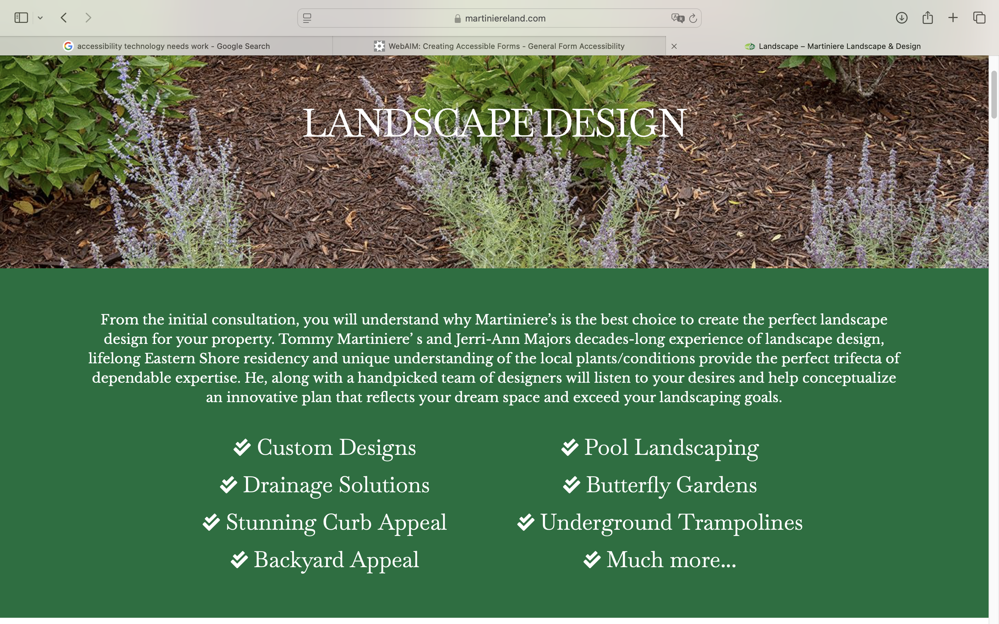

When these elements were missing or ambiguous, this led to a poor overall experience. As part of the usability evaluation, we observed users attempting to interact with areas of the site that they assumed would be clickable. This underscores the importance of intentional design, where every element serves a clear purpose and aligns with user needs.

An editor’s role in such scenarios extends beyond evaluating content to collaborating with designers and developers. Editors must ensure that buttons and other interactive elements are not only functional but also intuitively placed, labeled descriptively, and tested across devices and assistive technologies. For instance, a button labeled “Request Landscaping Quote” is far more effective than generic terms like “Submit” or “Click Here.” Moreover, editors advocate for features like focus indicators and keyboard navigation, ensuring these buttons are accessible to users with disabilities. This usability test experience illustrated how editors contribute to bridging the gap between content strategy and user experience. By identifying and addressing pain points in design and functionality, editors help create a cohesive, user-centered digital environment that meets the needs of diverse audiences.

Editors contribute to the accessibility of forms by ensuring that instructions, required fields, and formatting requirements are explicitly identified. They also review forms for keyboard operability, supporting users with mobility impairments who navigate web pages without a mouse. Recognizing that JavaScript interactions, such as auto focusing or dynamic changes, can inadvertently exclude users who rely on keyboard navigation, editors pay careful attention to these elements. Their efforts ensure forms are usable for all and reflect their broader role in fostering inclusivity (Web Accessibility in Mind, n.d.).

In addition, editors advocate for clear error messaging and validation, which are crucial for both usability and accessibility. Error messages should be easy to understand, clearly indicate what needs to be corrected, and be positioned near the relevant fields to minimize confusion. For instance, instead of a vague message like “Error: Invalid entry,” a more helpful message would specify, “Please enter a valid email address in this format: example@domain.com.” Editors also ensure error messages are conveyed through multiple cues, such as text and icons, to accommodate users with visual or cognitive impairments (Web Accessibility Initiative, 2021). These practices reduce frustration, guide users through the form process, and reflect the editor's role in enhancing clarity and inclusivity (Web Accessibility in Mind, n.d.).

Ultimately, an editor’s work transcends mere grammar and style corrections. It involves a commitment to creating content and interfaces that are not only clear and engaging but also accessible to everyone, reinforcing their critical role in promoting inclusivity and usability across platforms.

## Cognitive Benefits of Accessibility

Cognitive accessibility focuses on creating digital environments that accommodate individuals with learning or cognitive disabilities. This includes designing content that is easy to understand, navigate, and interact with, regardless of the user’s abilities (Bikkani, 2022). The WCAG provides global best practices for web accessibility, ensuring that content is usable by both disabled and non-disabled audiences. These guidelines emphasize inclusivity, demonstrating that accessible design benefits all users by improving clarity and usability.

For editors, accessibility is not a checklist but a mindset. It shapes every aspect of content creation, from typography and layout to functionality and interaction. However, accessibility considerations are sometimes unintentionally overlooked. For instance, in the cookbook publication I helped with, our team neglected to include alt text for the images accompanying the recipes, recipe instructions, and anecdotes. Although we carefully crafted the visuals to make the cookbook more engaging, we overlooked how users with visual impairments would interpret the content. The absence of alt text meant that essential details conveyed through images were inaccessible to individuals relying on screen readers. Additionally, the inclusion of a glossary or word list, explaining certain cooking terms, cultural terms, and ingredients could have been beneficial for readers with cognitive disabilities or those unfamiliar with certain culinary language. This oversight highlighted the importance of integrating accessibility principles from the outset to avoid creating barriers for certain users.

By prioritizing accessibility, editors fulfill their role as advocates for inclusion, ensuring that their work serves the broadest possible audience (Bikkani, 2022). Accessible design represents the intersection of practicality and compassion. It elevates user experience and underscores the editor’s commitment to equity. By embracing these principles, editors contribute to a more inclusive and interconnected world.

## Accessibility Improves CEO (Customer Experience Optimization)

One of the most significant advantages of accessibility is its ability to enhance the user experience for all. Accessibility ensures that every individual, including those with disabilities, can engage with content and services seamlessly. For editors, this means designing documents, websites, and materials that are intuitive and user-friendly. A core aspect of accessibility is anticipating and addressing barriers before they arise. Editors achieve this by employing strategies such as logical heading structures, readable fonts, descriptive alt text, and captions for audiovisual content. These elements not only aid individuals with disabilities but also improve the experience for all users. For example, captions benefit people who are deaf or hard of hearing, as well as users in noisy environments or non-native speakers (Why Accessibility Matters, 2023).

In a cookbook publication I contributed to, our team overlooked an essential accessibility feature—alt text for images. This omission meant that visually impaired users relying on screen readers could not fully experience the recipes, instructions, or accompanying visuals. The inclusion of descriptive alt text and a glossary for culinary terms could have broadened the cookbook’s usability and inclusivity. This oversight served as a powerful reminder of the editor’s responsibility to consider accessibility at every stage of the process. It demonstrated that inclusive design doesn’t just benefit users with disabilities, it enhances the experience for everyone (Bikkani, 2022).

The inclusion of accessibility in design also ties into CEO (Customer Experience Optimization), as it enhances overall satisfaction and engagement for all users. By prioritizing accessibility, editors help create a user-friendly experience that is not only functional but also empathetic. This approach fosters loyalty, as customers appreciate when companies provide content that is easy to navigate and engage with, regardless of their abilities (Why Accessibility Matters, 2023).

Editors, therefore, become architects of inclusive experiences. Their work ensures that users can interact with content effortlessly, fostering satisfaction and loyalty. As accessibility continues to shape customer expectations, editors play an indispensable role in optimizing experiences for diverse audiences (Why Accessibility Matters, 2023).

## Enhancing Brand Image Through Accessibility

In a socially conscious marketplace, organizations that prioritize accessibility are seen as ethical, innovative, and inclusive. Editors contribute significantly to this perception by embedding accessibility into the brand’s communication strategies. For instance, an accessible website signals that a company values all its customers, not just those without disabilities. Editors who champion accessibility help build a brand image rooted in inclusivity and respect, which drives customer loyalty and sets the organization apart from competitors (Why Accessibility Matters, 2023).

In the cookbook publication I contributed to, we carefully designed elements to enhance the visual appeal and reader engagement. For example, we bolded contributors’ names following “Submitted by” and used a distinct color for the dish titles to create a personalized and polished appearance. These choices helped differentiate the content sections and emphasized contributor recognition.

However, we had an opportunity to enhance functionality by bolding the headings “Ingredients” and “Instructions.” While these headings were formatted consistently throughout the book, additional emphasis through bold text of the headings “Ingredients” and Instructions” established a clearer visual hierarchy, improving usability for readers skimming or navigating the pages. This adjustment is valuable for those seeking quick reference to specific sections. For an example of this formatting, see Figure 7. This visual illustrates how bolding further enhanced the ease of use while maintaining the aesthetic quality of the publication.

Figure 7: Top of a recipe page from Culinary Chronicles with bolded headings and contributor details

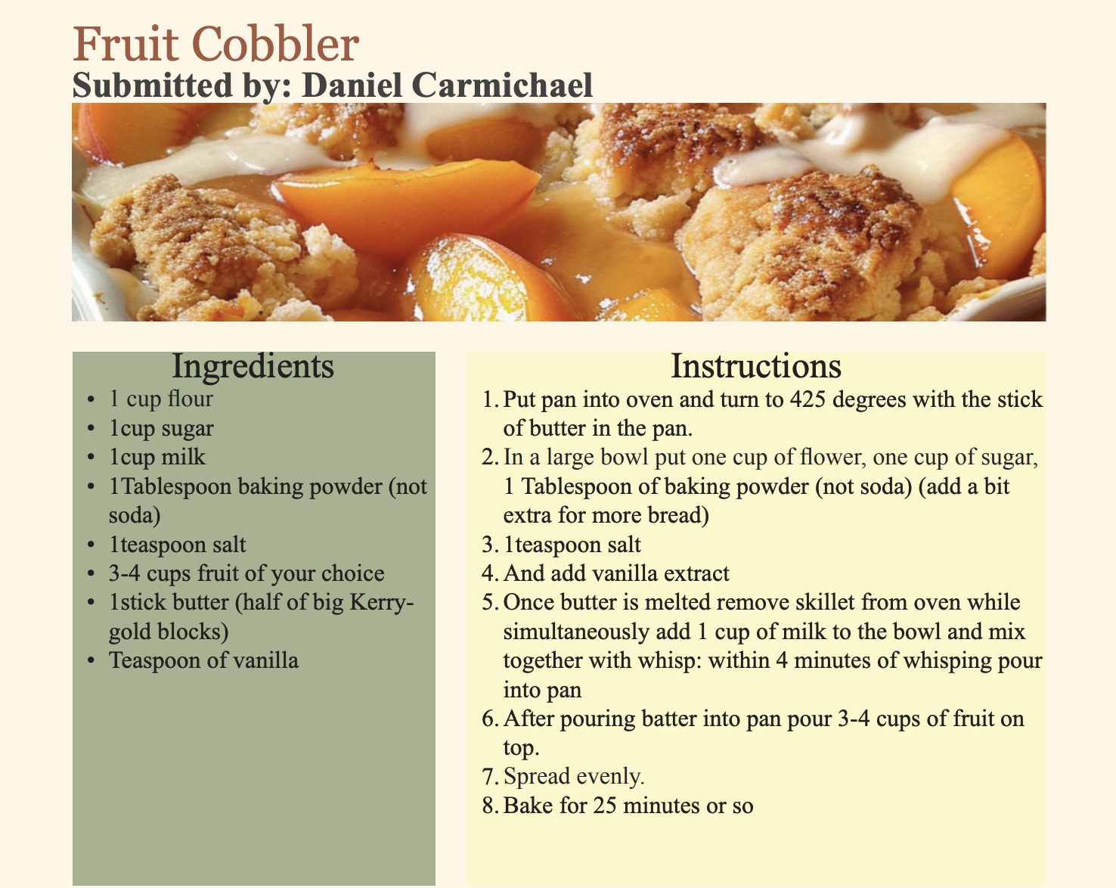

A reader scanning the recipe can quickly identify the preparation steps because the “Instructions” heading on each page was bolded. Having this visual distinction, even a small cognitive load was introduced, particularly for individuals with learning or visual processing challenges. Enhancing the headings made the cookbook more user-friendly and accessible to a broader audience, including those who benefit from improved readability and structure.

Furthermore, while anecdotes accompanying the recipes were carefully curated to add personality and context, we didn’t prioritize making these sections equally distinct from the functional parts of the recipe. Incorporating additional formatting adjustments, such as italicizing anecdotes or positioning them as a sidebar, could have further refined the reader’s experience by visually separating storytelling from instructional content. We just put the anecdotes at the bottom of each page right beside the contributor’s photo that they had submitted to us, example shown in Figure 8.

Figure 8: Example illustration of an anecdote in Culinary Chronicles

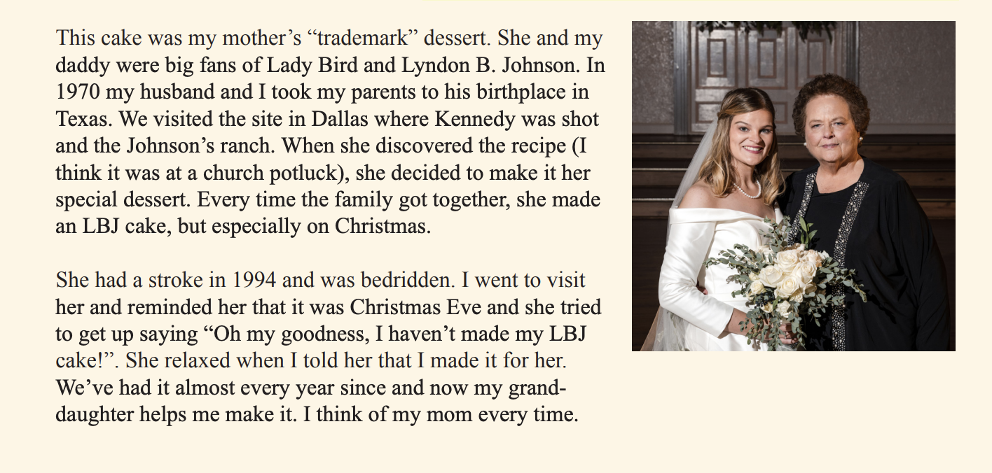

These observations emphasize that while we achieved consistent formatting, we missed opportunities to apply accessibility principles to strengthen clarity and usability. This highlights the editor’s responsibility not only to maintain aesthetic consistency but also to ensure functionality and inclusivity in every design decision (Why Accessibility Matters, 2023).

## Testing for Accessibility

Accessibility testing is a process that evaluates digital products and services to ensure that people with disabilities can use them. Accessibility testing aims to create an inclusive digital environment by removing barriers that prevent people from accessing digital products and services. A form of testing for accessibility that my peers and I in ENGL 7000: Technical Editing conducted involved running some documents through an Accessibility Check. As editors, this practice emphasizes the critical role we play in creating content that meets the diverse needs of users.

One assignment in class had us working with PDFs in Adobe Acrobat. We checked text and images, added captions to images, included alt text, tagged the document, and adjusted specific text boxes to improve accessibility. This process exemplifies an editor's responsibility to ensure all elements of a document are accessible and formatted appropriately for users with varying abilities. For example, we ran an Auburn University manual through the Accessibility Checker in Adobe Acrobat, which identified numerous inaccessible elements. As editors, it was our role to address these issues and improve the document's usability for all.

Another assignment, completed as homework, involved editing content from the Myotonic Goat Registry website for audience, purpose, and context. This activity required me to approach the content with the perspective of an editor committed to accessibility. Figure 9 illustrates the disorganized text prior to my revisions: a bundle of jumbled sentences and unnecessary information. Poorly structured text can be particularly challenging for individuals with disabilities, such as those with dyslexia, who may already experience letters, sequences, and numbers as jumbled (Seiple, 2022). Additionally, individuals with low vision or other disabilities would encounter similar difficulties due to the lack of logical organization. As editors, we bear the responsibility to restructure and clarify content to enhance accessibility for all users.

These assignments underscore the integral role of editors in fostering inclusivity. By prioritizing accessibility, editors not only improve the readability and usability of content but also ensure that it aligns with best practices in universal design. This commitment is essential to creating equitable digital environments where everyone can fully participate.

Figure 9: Original body of text from The Myotonic Goat Registry

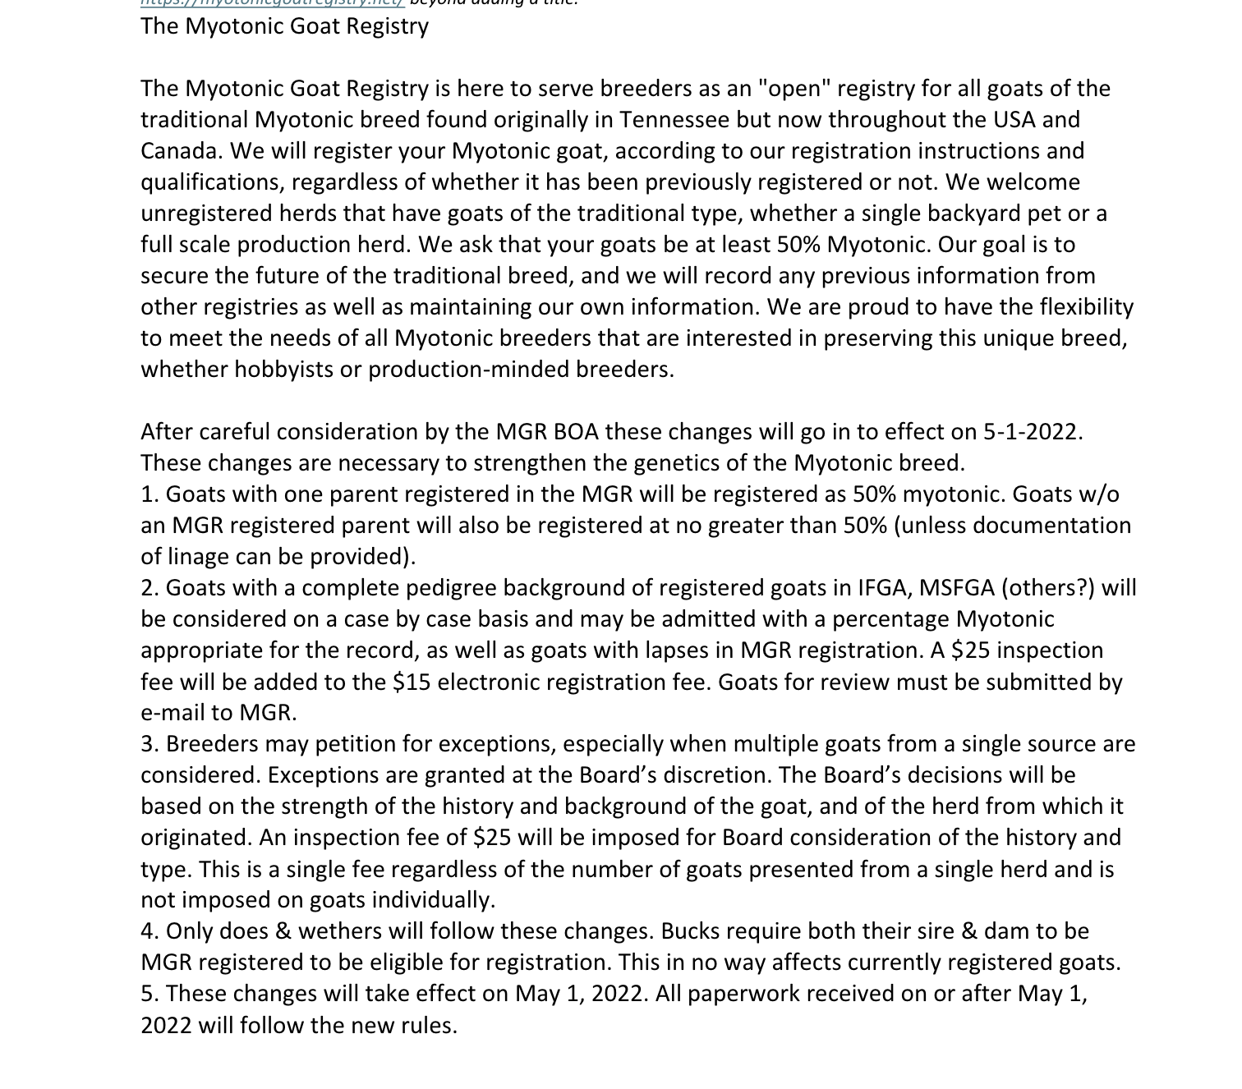

I revised the text to improve its clarity and readability. First, I condensed lengthy sentences into a more concise form, making the content easier to understand. I then focused on the numbered list, restructuring it by adding descriptive subheadings and bullet points, as shown in Figure 10. Subheadings help users quickly identify sections, while bullet points present information in an organized, scannable format. Using bullet points is a proven method to enhance accessibility, as they add visual structure and make web pages easier to navigate. This is particularly beneficial for users with cognitive disabilities or those who rely on screen readers, as bullet points enable them to grasp key ideas more effectively. They also contribute to overall usability by breaking up dense paragraphs and improving content flow (Bureau of Internet Accessibility, n.d.).

Figure 10: Edited version of the Myotonic Goat Registry

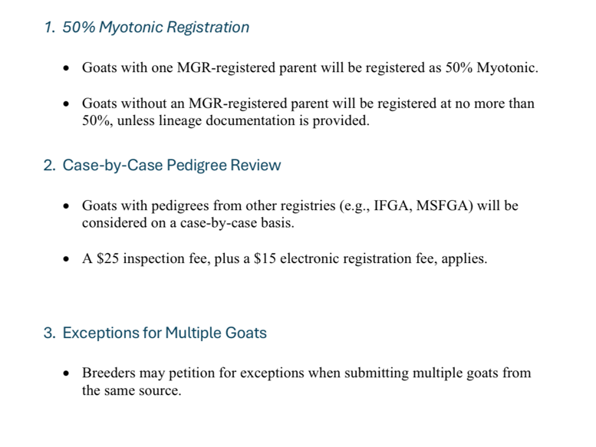

Furthermore, bullet points align with best practices in web accessibility by providing a clear hierarchy of information. This approach benefits all users, especially those with disabilities, by ensuring content is both visually and contextually accessible. As research highlights, accessible design is not only an inclusive practice but also helps broaden the audience reach and user satisfaction (Bureau of Internet Accessibility, n.d.).

Accessibility is not just a checklist or a set of guidelines. It is a commitment to creating content that can be understood and used by everyone, regardless of ability. For editors, this means taking responsibility for ensuring that every aspect of a publication, whether it’s text, images, or interactive elements, meets accessibility standards. Throughout this report, I explored the importance of legible text, accessible typography, screen readers, text-to-speech tools, alternative text, color contrast, and accessible links, buttons, and forms. I also examined how accessibility improves cognitive usability, enhances brand image, and boosts user engagement, all while contributing to an inclusive user experience.

Being an editor means more than crafting polished prose; it requires a critical eye for how content functions in diverse contexts. An editor must think beyond the written word, “outside the box” people might say, addressing the needs of individuals who rely on assistive technologies or alternative formats. Testing for accessibility is a fundamental step in the editorial process, ensuring that the content not only adheres to legal standards but also aligns with ethical practices of inclusivity.

The examples and assignments that I mentioned demonstrate how accessibility can be integrated into editorial workflows, including assessing the accessibility of a cookbook publication and identifying areas for improvement. These exercises underscore that accessibility is not just a technical concern, it is a core value of modern publishing.

Ultimately, being an editor who prioritizes accessibility means advocating for equity in communication. It is about recognizing that accessibility is not optional; it is an essential aspect of professional integrity. By embracing accessibility, editors uphold the principles of inclusion while enhancing the quality and reach of the content they produce.

References:

Accessibility Bytes No. 4: Descriptive Links and Hypertext. (n.d.). Retrieved from

<https://www.section508.gov/blog/accessibility-bytes/descriptive-links-and-hypertext/>.

Bikkani, A. (2022). The Complete Guide to what Cognitive Accessibility Means and how it affects user

experience. Retrieved from <https://advancedbytez.com/complete-guide-to-cognitive-accessibility/>

[accessibility/](https://advancedbytez.com/complete-guide-to-cognitive-accessibility/).

Bradham, J. (2024). One button to rule them all: Making accessible buttons. Retrieved from

<https://jessijokes.medium.com/one-button-to-rule-them-all-465e294cba82>.

Bureau of Internet Accessibility. (n.d.). *Do bullet points help with accessibility?* BOIA Blog. Retrieved

December 9, 2024, from <https://www.boia.org/blog/do-bullet-points-help-with-accessibility>.

Button Accessibility: Creating Accessible Buttons. (n.d.). Retrieved from

<https://accessiblyapp.com/web-accessibility/buttons/>.

Color Contrast. (2023). Retrieved from [https://www.chhs.colostate.edu/accessibility/best-practices-how-](https://www.chhs.colostate.edu/accessibility/best-practices-how-tos/color-contrast/)

[tos/color-contrast/](https://www.chhs.colostate.edu/accessibility/best-practices-how-tos/color-contrast/).

Content Creation: Authoring Meaningful Alternative Text. (n.d.). Retrieved from

<https://www.section508.gov/create/alternative-text/>

Creating Accessible Forms: General Form Accessibility. (n.d.). Retrieved from

<https://webaim.org/techniques/forms/>.

Elliott, D., & Hogle, P. S. (2020). How to write great alt text - and why it matters. Retrieved from

<https://aceseditors.org/news/2020/how-to-write-great-alt-text-and-why-it-matters>

Ellis, D. R. (2023). Best Fonts for Accessibility and Visually Impaired Users [ADA-Compliant Fonts].

Retrieved from <https://blog.hubspot.com/website/accessibility-fonts#:~:text=Verdana%20is%20another%20accessibility%20font,the%20text%20easier%20to%20read>.

Freedom Scientific. (n.d.). *JAWS: Screen reading software*. Freedom Scientific. Retrieved December 9,

2024, from <https://www.freedomscientific.com/products/software/jaws/>.

Horton, B. (n.d.). A review of The Voice Dream Reader for IOS: A one-stop solution. Retrieved from

<https://www.afb.org/aw/14/8/15662>.

New York State Education Department. (n.d.). *Create accessible hypertext links*. New York State

Education Department. Retrieved December 9, 2024, from

<https://www.nysed.gov/webaccess/create-accessible-hypertext-links>.

Puglisi, A. (2017, February 6). *Using text-to-speech software as an editing tool.* Writers Helping Writers.

Retrieved November 7, 2024, from <https://writershelpingwriters.net/2017/02/using-text-to-speech-software-as-an-editing-tool/>.

Recite Me. (2024, October 17). *Assistive technology for the blind and visually impaired*.

<https://reciteme.com/us/news/assistive-technology-for-the-blind-and-visually-impaired/#:~:text>.

Seiple, T. (2022, March 31). *Accessibility, fonts, and dyslexia.* Medium.

<https://medium.com/codex/accessibility-fonts-and-dyslexia-3cc495795127>.

UNC School of Medicine. (n.d.). *Headings and accessibility*. University of North Carolina at Chapel Hill.

<https://www.med.unc.edu/webguide/accessibility/headings/>.

U.S. General Services Administration. (n.d.). *Fonts & typography*. Section508.gov. Retrieved November

13, 2024, from <https://www.section508.gov/develop/fonts-typography/>.

Wake Forest University. (n.d.). *Text-to-speech*. Wake Forest University Accessibility Resources.

Retrieved November 7, 2024, from [https://accessibility.wfu.edu/resources/assistive-technology/text-to-speech/.](https://accessibility.wfu.edu/resources/assistive-technology/text-to-speech/)

Why Accessibility Matters: A CEO’s Responsibility in Creating an Inclusive Society - CEE Multi-

Country News Center. (2023). Retrieved from <https://news.microsoft.com/en-cee/2023/05/18/why-accessibility-matters-a-ceos-responsibility-in-creating-an-inclusive-society/>.

Yale University. (n.d.). *Benefits of headings*. Yale University Usability & Web Accessibility. Retrieved

November 6, 2024, from <https://usability.yale.edu/web-accessibility/articles/headings>.